New Dis-Eur-England-Northfleet-Kent-Clactonian Biface-424,000 BP-374,000 BP

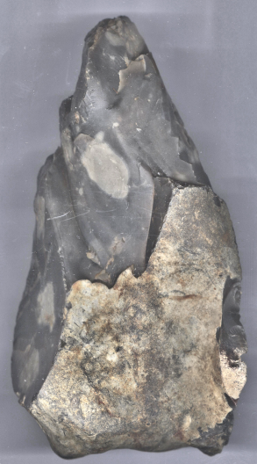

Fig, 1. Northfleet-Kent-Clactonian Biface-424,000 BP-374,000 BP-dorsal view

Fig. 2. A reconstruction of *Homo erectus* at the Westfälisches Landesmuseum, Herne, Germany, in a 2006 exhibition. From https://upload.wikimedia.org/wikipedia/commons/thumb/c/cb/Homo_erectus_new.JPG/200px-Homo_erectus_new.JPG

**Formal Label:** England- Northfleet-Kent-Clactonian Biface-424,000 BP-374,000 BP

**Display description:**

This Clactonian flint tool was made by *Homo erectus* in the early Hoxnian Interglacial, (Marine Isotope Stage 11, 424,000 BP-374,000 BP (Lisiecki and Raymo 2005; Stringer 2006) and may have been used for hunting Pleistocene animals including the straight-tusked elephant *(Palaeoloxodon antiquus*) (Glass 2016) and the giant hippopotamus, (Hippopotamus amphibius) (Schreve 2009**;** Tester 1984). Clactonian refers to the flint tools found in a paleo-channel at Clacton-on-Sea in Essex, England, in 1911 (Warren 1922). The present tool was found in Northfleet, near the destroyed flint quarries of Barnfield Pit and Rickson's Pit, Swanscombe, Kent County, England, previously noted for their Clactonian artifacts (Darvill, 30 Jan 2017; Tester 1984).

**Accession Number:**

**LC Classification:** GN772.22.G7

**Date or Time Horizon:** 424,000 BP-374,000 BP

**Geographical Area:** Northfleet near Swanscombe, Kent

**Map, GPS Coordinates:** from Keith 1916

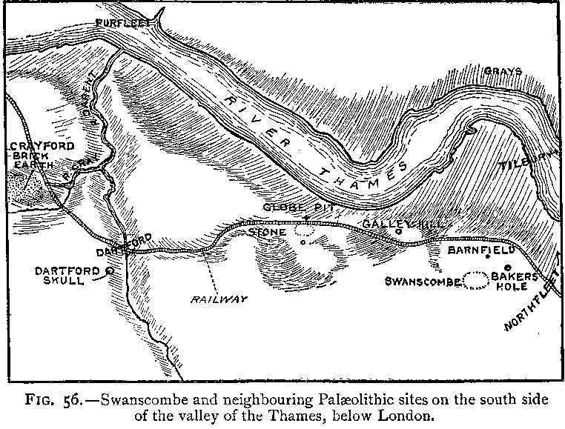

**Cultural Affiliation:** Lower Paleolithic, Clactonian

**Medium:** Flint

**Dimensions: H 18 cm; W 11 cm.  
Weight:**

**Provenance: Old English collection from 1920’s**

**Condition:** original with ancient patination.

**Discussion:** This Clactonian biface, 424,000 BP-374,000 BP found near Swanscombe, Kent, has been flaked from a thick elongated flint cobble and has been bifacially worked to form a robust distal point. The dorsal side retains a large cortical area at the proximal end; this cortical area continues along the right lateral edge and around the proximal end which is naturally rounded, being the surface of the flint cobble. The ventral side has been finished with retouches to the distal end. The prominent bulb of percussion on the flakes indicates use of a hammerstone for more controlled and regulated shapes than was possible with the Olduwan technology.

**References:**

Conway, Bernard, John McNabb and Nick Ashton, eds.. 1996. *Excavations at Barnfield Pit,* *Swanscombe, 1968-72*; illustrations by Phil Dean. London: Dept. of Prehistoric and Romano-British Antiquities.

Darvill, J. 2017. Pers. comm. 30 Jan. 11, ME19 5LH, UK.

Glass, Helen. 2004. “Stone Age elephant remains found,” BBC News, 19 June. <http://news.bbc.co.uk/2/hi/uk_news/england/kent/3821527.stm>. Retrieved 1 Feb 2017.

Keith, Arthur. 1915. *The Antiquity of Man*. London.

Lisiecki, Lorraine E. and Maureen E. Raymo. 2005. [*"A Pliocene-Pleistocene stack of 57 globally distributed benthic δ18O records"*](http://www.lorraine-lisiecki.com/LR04_MISboundaries.txt). <http://www.lorraine-lisiecki.com/LR04_MISboundaries.txt>. Retrieved 1 Feb 2017.

## McNabb, John. 2007. *The British Lower Palaeolithic: stones in contention*. London, New York: Routledge.

# Schreve, Danielle C. 2009. “A new record of Pleistocene hippopotamus from River Severn terrace deposits, Gloucester, UK—palaeoenvironmental setting and stratigraphical significance,” *Proceedings of the Geologists' Association*, 120 (1): 58–64.

Stringer, Chris. 2006. Homo Britannicus: The incredible story of human life in Britain. London: Penguin.

Tester, P. J. (1984). "Clactonian Flints from Rickson's Pit, Swanscombe," Archaeologia Cantiana, Kent Archaeological Society. Retrieved 1 Feb 2017.

Warren, S. H. 1922. “The Mesvinian Industry of Clacton-on-Sea,” Proceedings of the Prehistoric Society of East Anglia, 3: 597-602.